IBM Employee HR Attrition

3X Data Mining

Mohammed Topiwalla, Patricia Londono, Sanchita Kumari, Valerio Trotta, Igor Pedevani, Millicent Ottchere



# Problem Statement

**How can we reduce IBM company's attrition rate by predicting if a candidate will exit in India within the year?**

* **S**pecific :- To Indian geography in IBM
* **M**easurable:- To reduce attrition rate(By at least 5%)
* **A**ction oriented:- Reduce employee attrition & suggest employee engagement & satisfaction programs
* **R**elevant:- Direct impact on company's top and bottom line
* **T**ime bound :- 12 months

Our client is IBM a leading firm and in the IT sector. It is recently facing a steep increase in its employee attrition . Employee attrition has gone up from 14% to 25% in the last 1 year . We are asked to prepare a strategy to immediately tackle this issue such that the firm’s business is not hampered and also to propose an efficient employee satisfaction program for the long run. Currently, no such program  is in place . Further salary hikes are not an option.

The attrition problem is not only unique to ibm but to other IT companies such as Infosys, India’s second largest IT services company, that is also battling high attrition, with a peak attrition of 20.4 % in the October-December quarter of FY15.

## **Methodology to solve the problem**

## **Converting Business problem to Data Science problem**

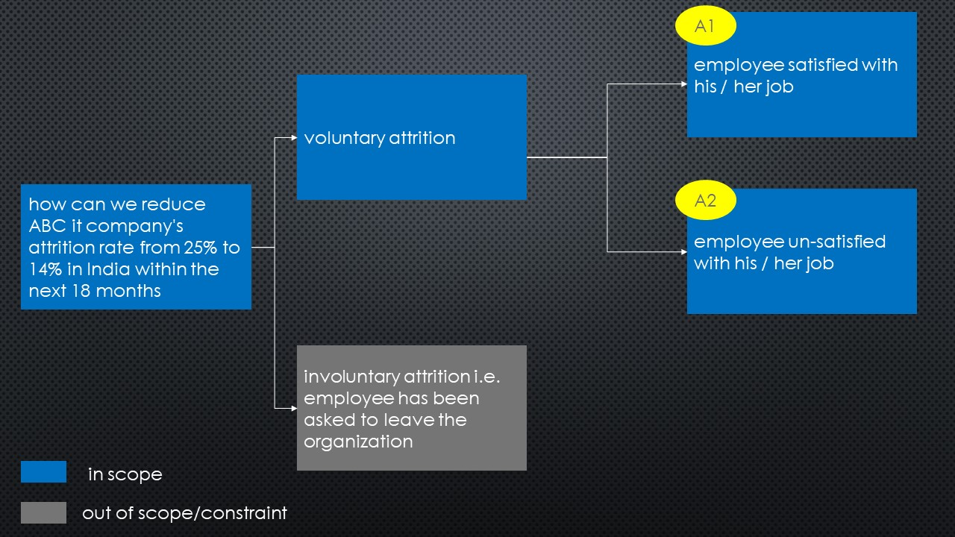

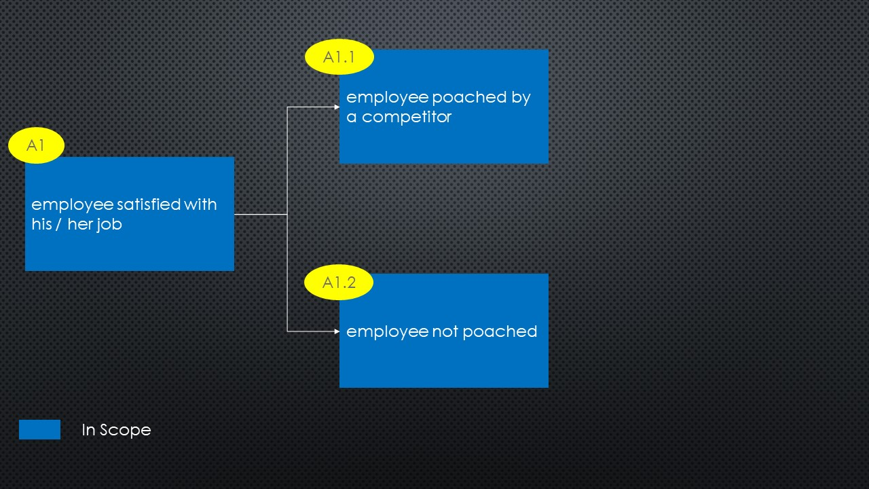

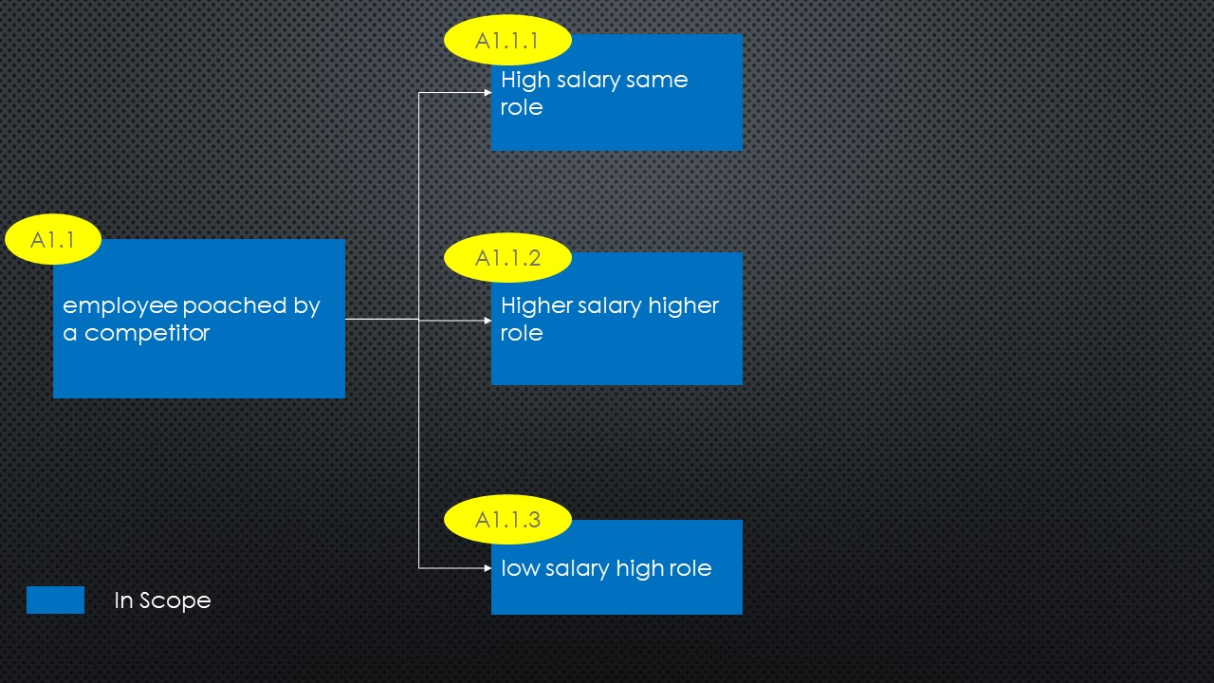

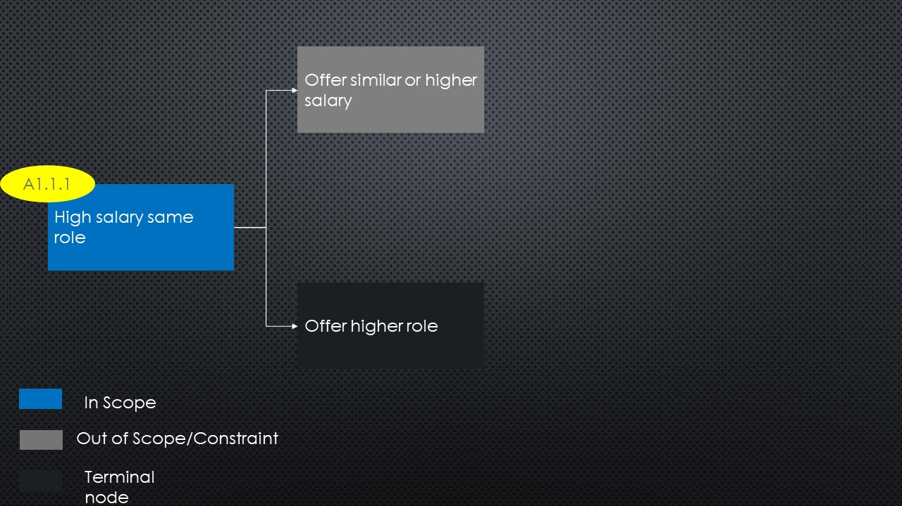

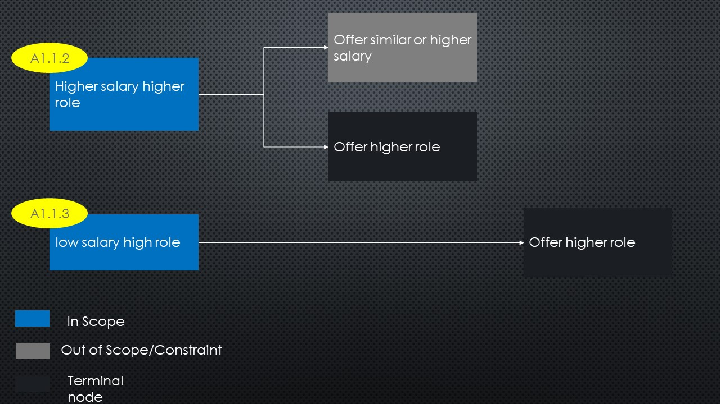

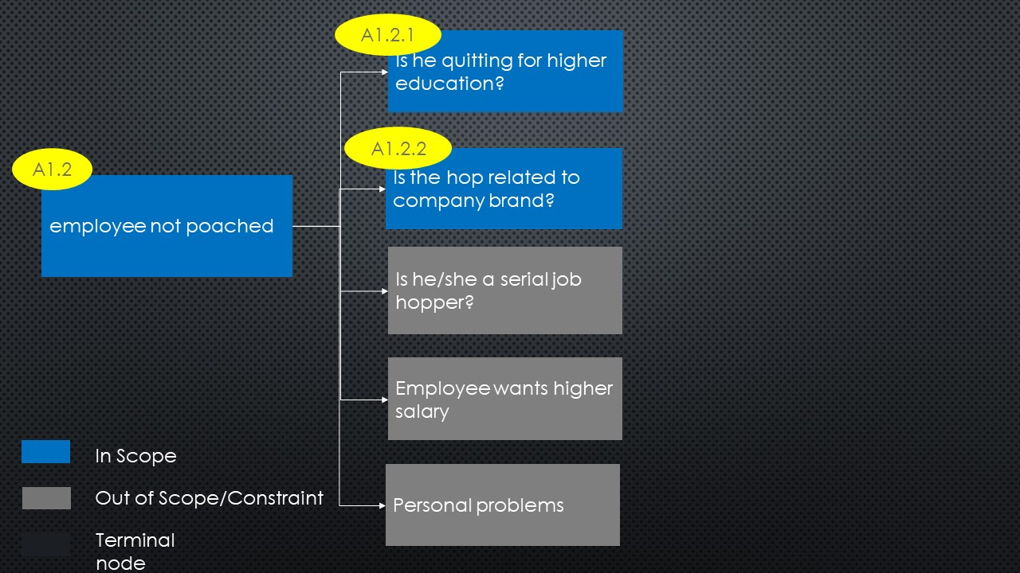

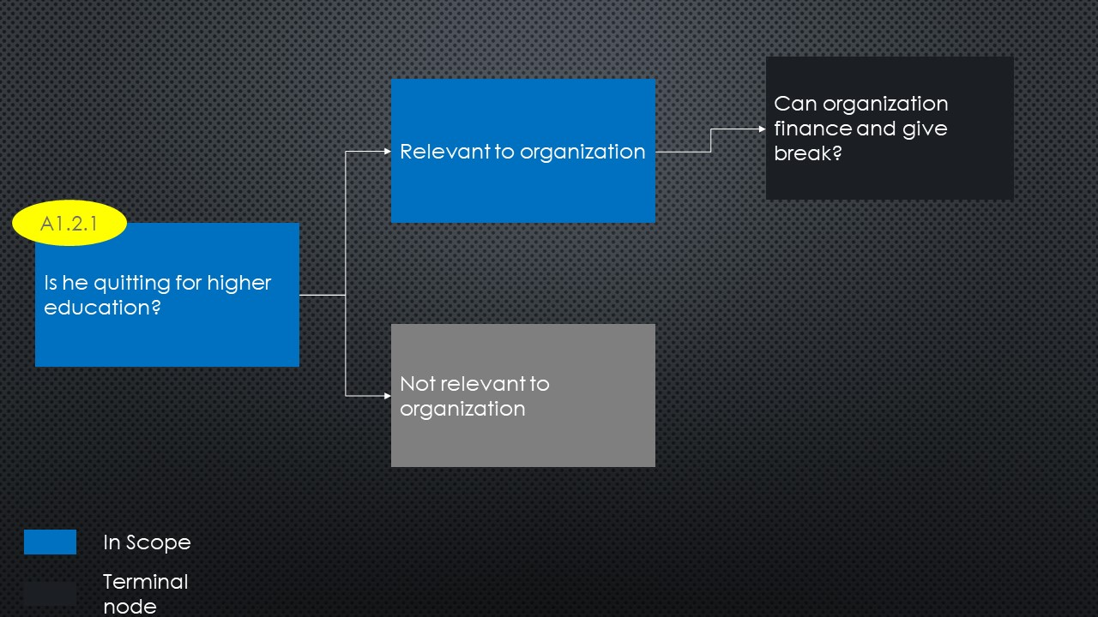

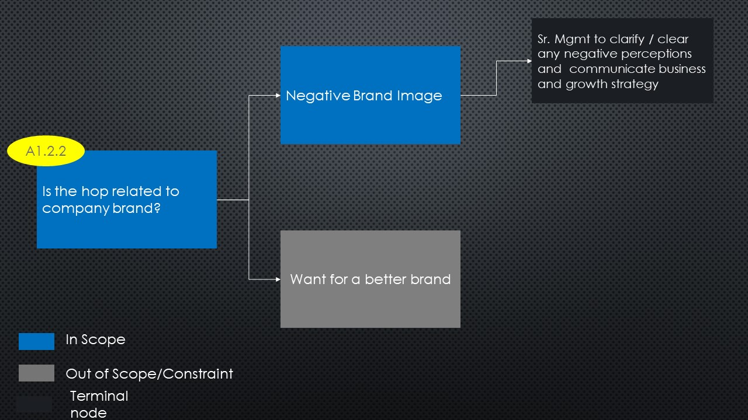

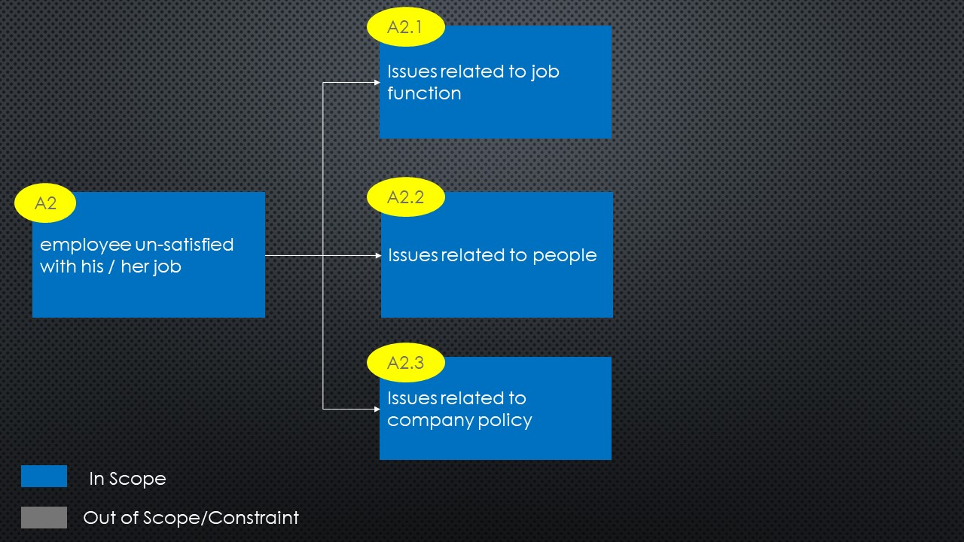

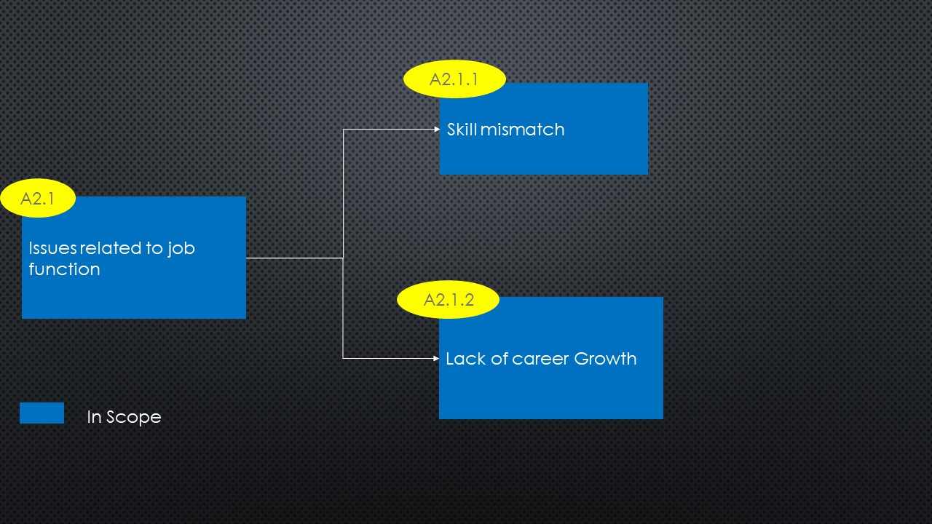

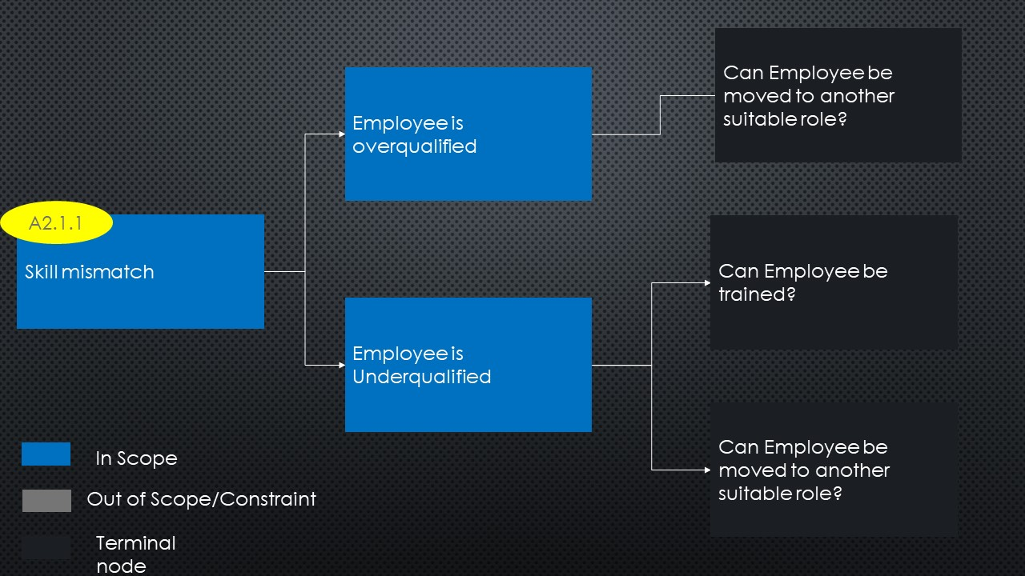

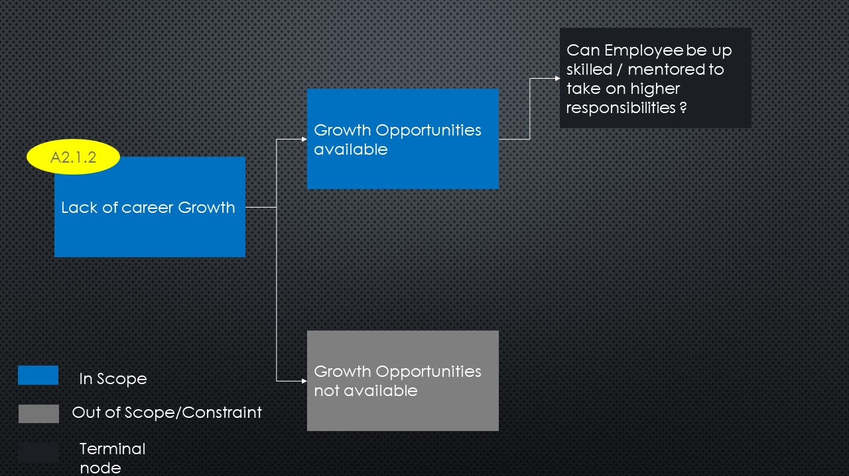

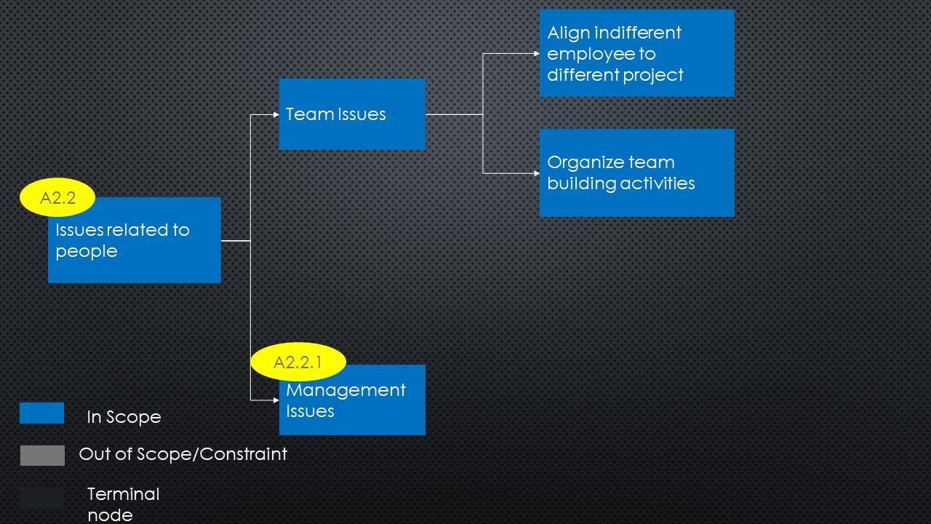

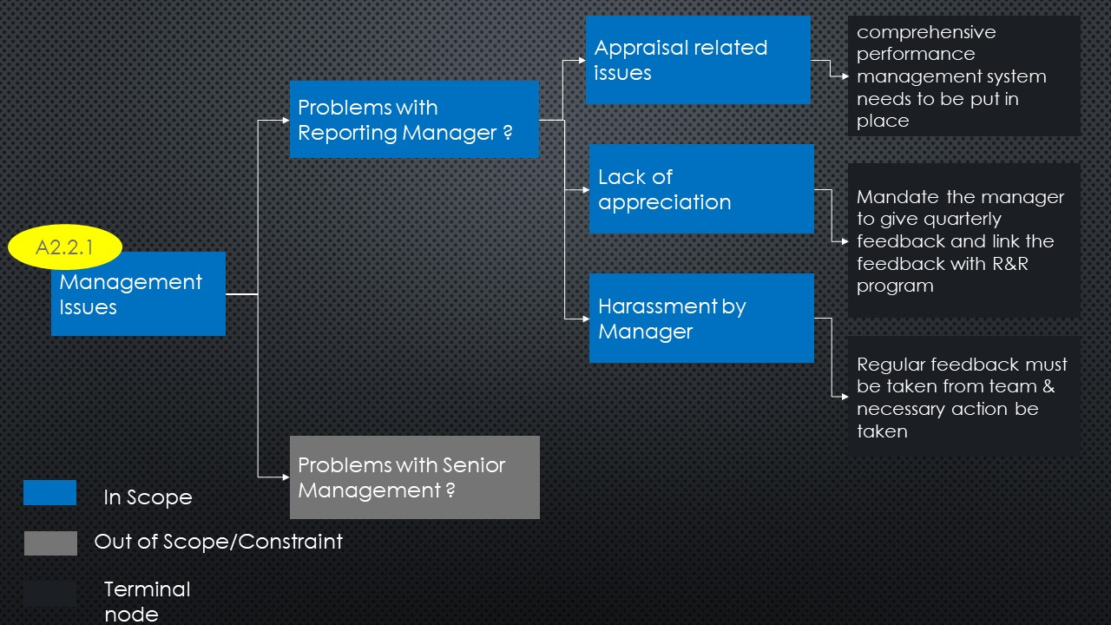

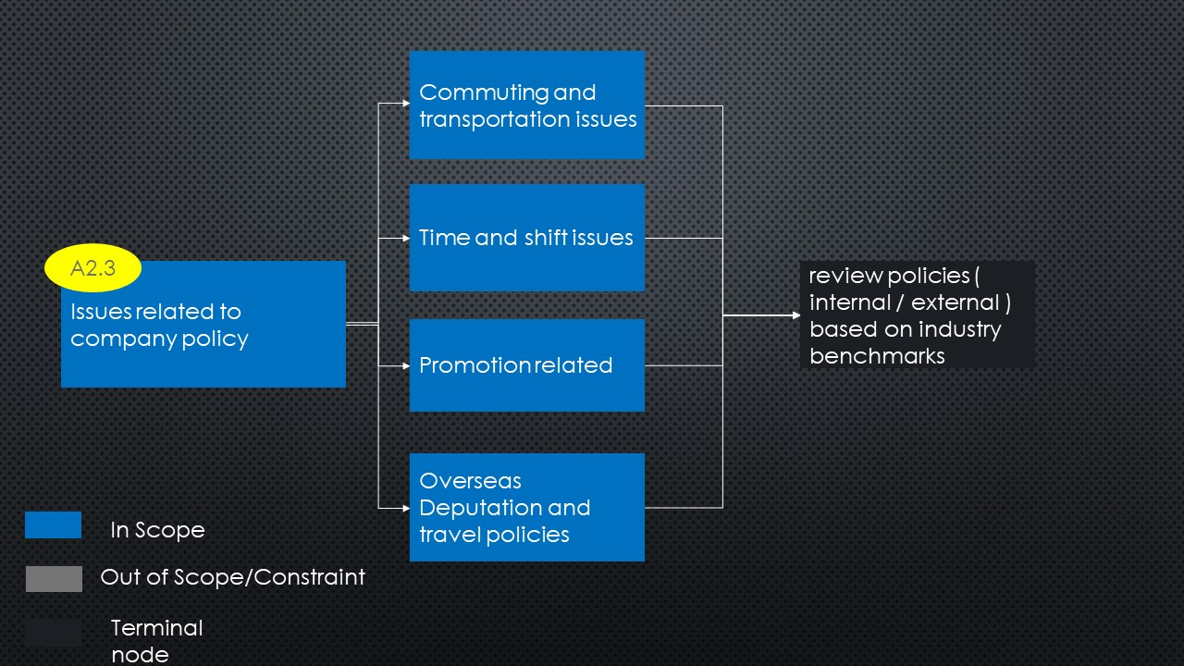

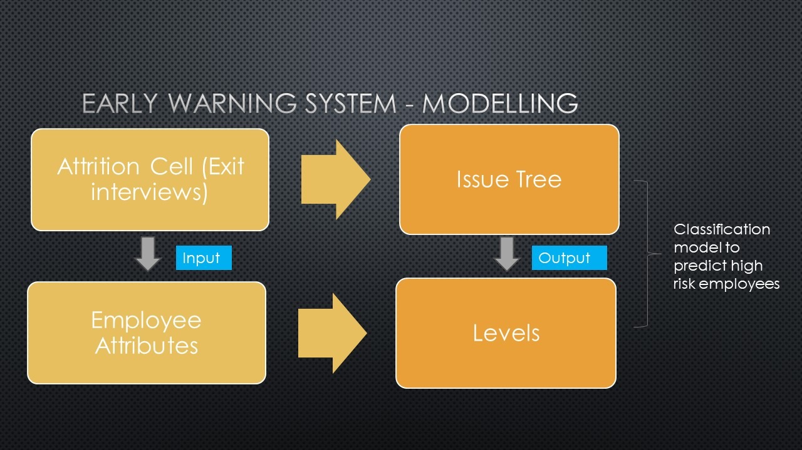

Who made this – Mohammed, Millicent

Who reviewed this – Sanchita, Igor

## **Exploratory Data Analysis**

* We were blessed with an excellent data set, the source of data is [here](https://www.kaggle.com/pavansubhasht/ibm-hr-analytics-attrition-dataset)
* There were no nulls or blanks in our data set
* The only thing which was visible from miles away was the class imbalance 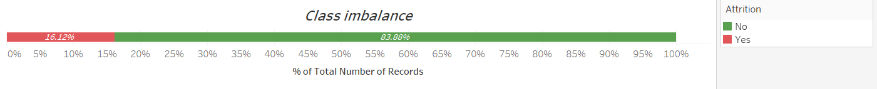
* The following insights were drawn from the EDA performed in Tableau
  + The age group of IBM employees in this data set is concentrated between 25-45 years
  + Attrition is more common in the younger age groups and it is more likely with females As Expected it is more common amongst single Employees
  + People who leave the company get lower opportunities to travel the company
  + People having very high education tend to have lower attrition
  + The correlation plot was as expected
  + Link to eda workbook in python is [here](https://github.com/mmd52/3XDataMining/blob/master/EDA_UnderstandingData.ipynb)
  + From the Tableau plots we can conclude that below mentioned category are having higher attrition rate:
    - Sales department among all the departments
    - Human Resources and Technical Degree in Education
    - Single’s in Marital status (Will not use this due to GDPR)
    - Male in comparison to females in Gender (Will not use this due to GDPR)
    - Employee with job satisfaction value 1
    - Job level 1 in job level
    - Life balance having value 1
    - Employee staying at distant place
    - Environment Satisfaction value 1
  + Link to Tableau workbook for EDA is [here](https://github.com/mmd52/3XDataMining/blob/master/IBM_Attrition.twbx)

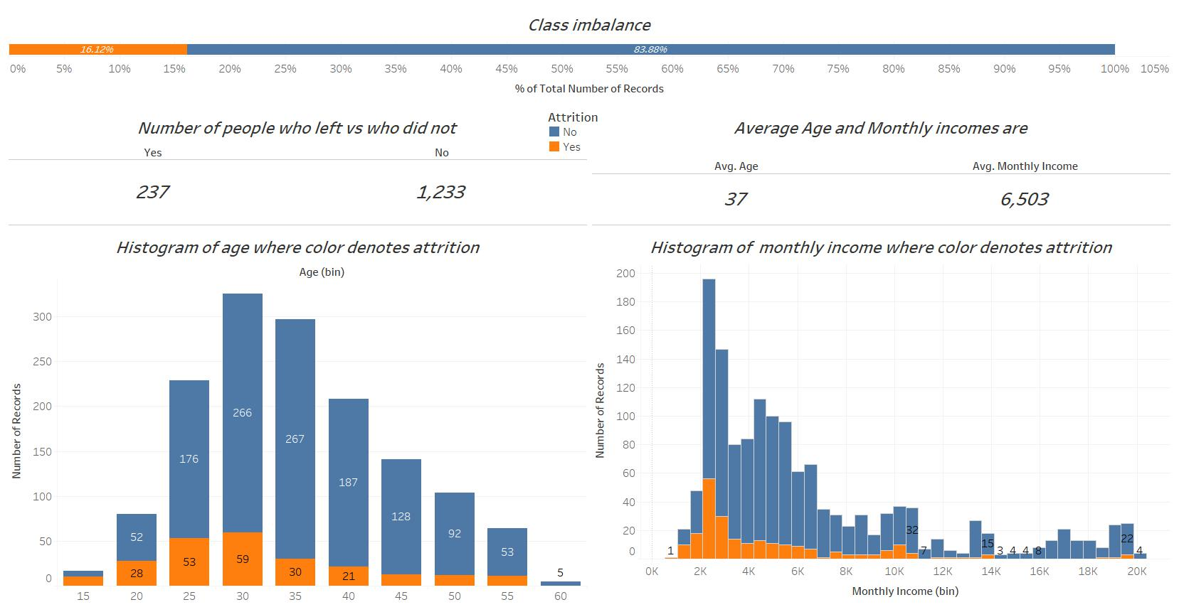

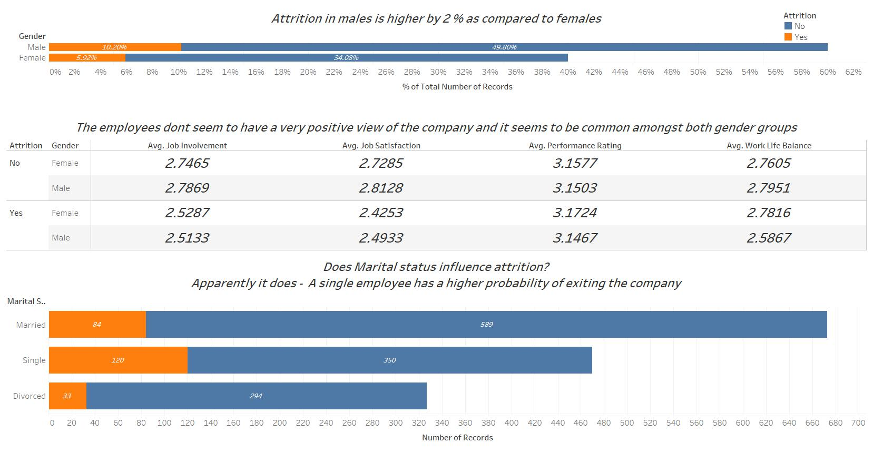

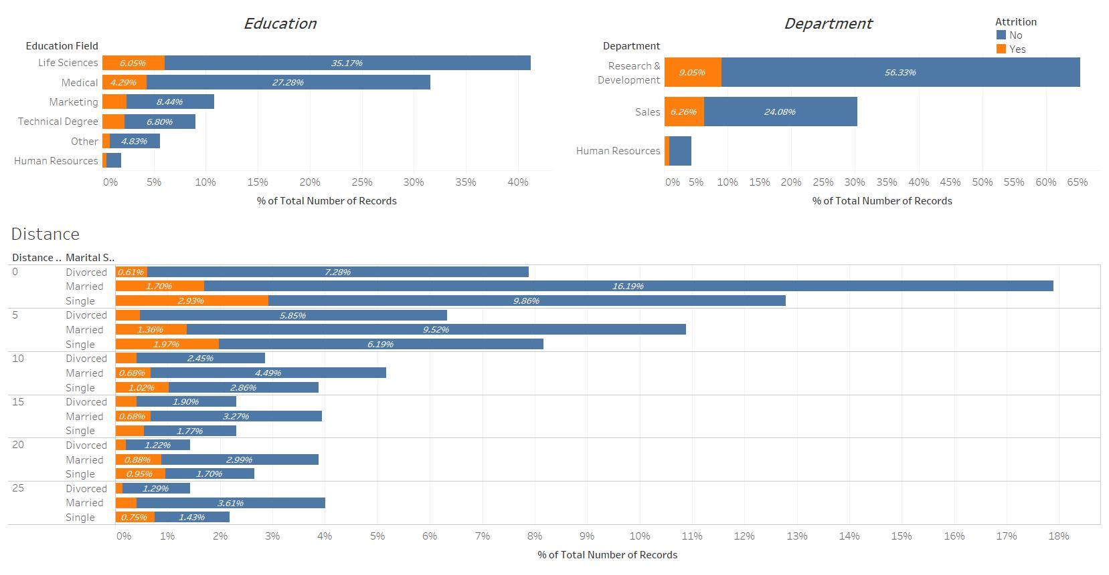

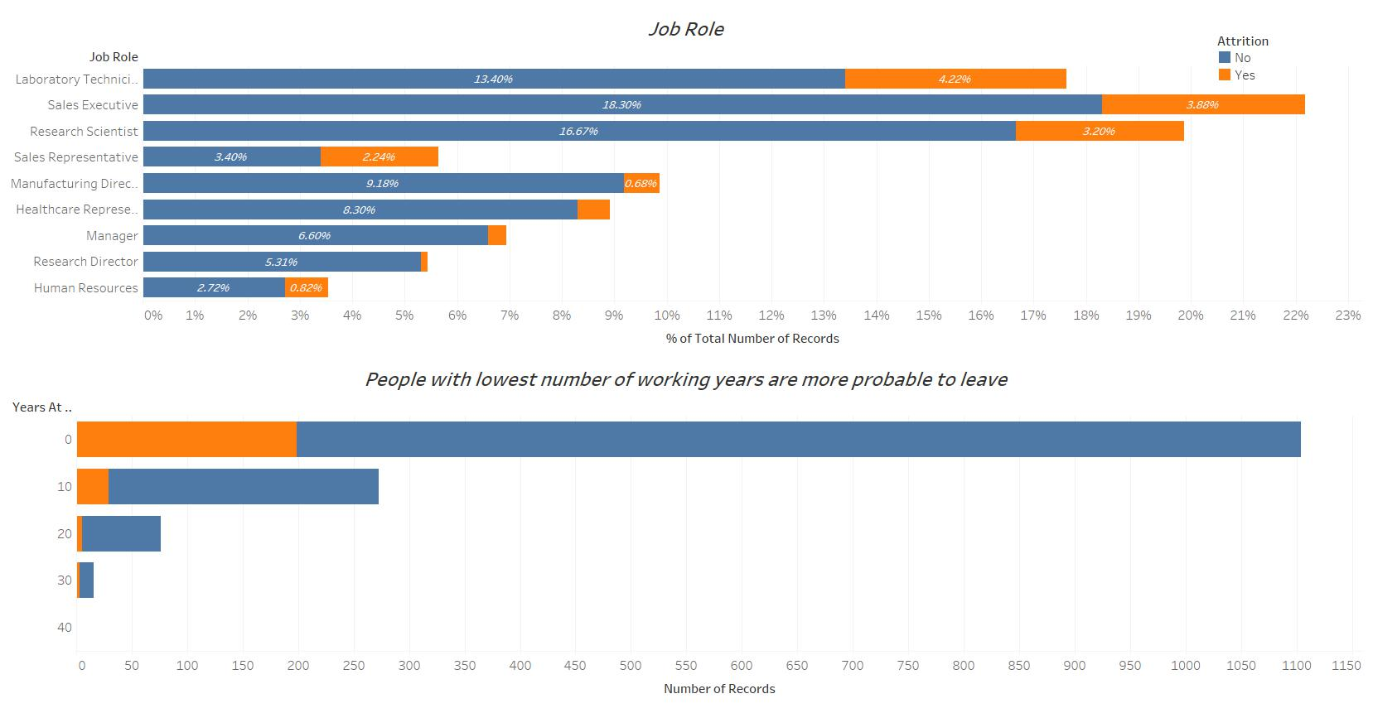

Who made this – 1) Tableau – Sanchita 2) Python - Mohammed

Who reviewed this – All group members

## **Feature Selection**

The following programs were used for Feature Selection:

**Weka:**

Classifier Attribute Evaluation, Correlation Attribute Evaluation and Gain Ratio Attribute Evaluation. The chart below summarizes the results that these models found (higher peaks show most important features).

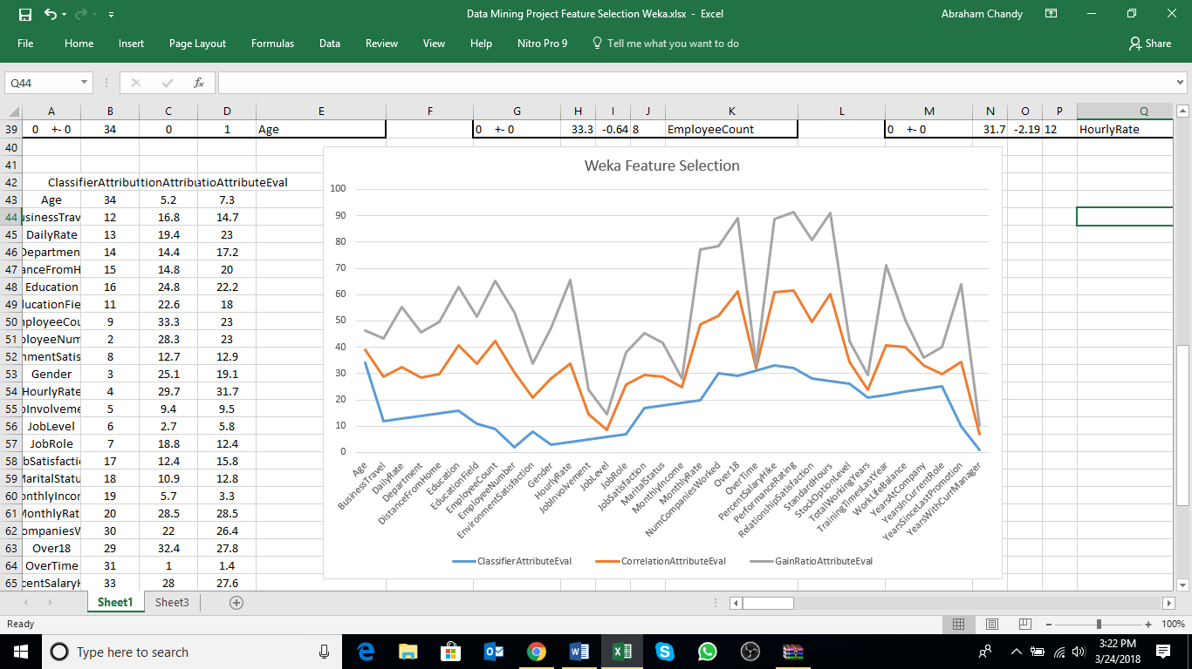

A Correlation based feature selection Subset Evaluation method was also run which proved to be the most useful in improving the accuracy of our classifier model. You can read about this feature selection method <https://www.cs.waikato.ac.nz/~mhall/thesis.pdf> .

See results below (Pink bars show the most important features):

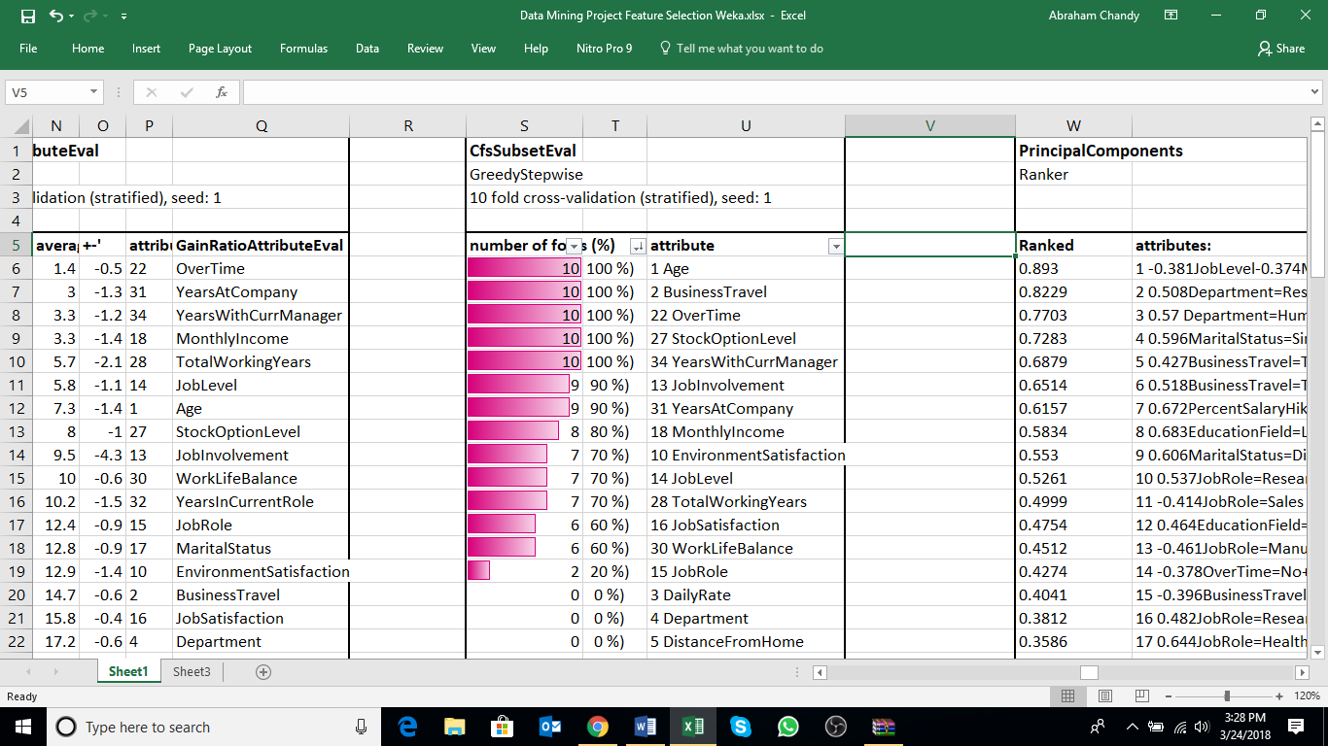

See excel file attached containing full reports for each of the methods explained above [here](https://github.com/mmd52/3XDataMining/blob/master/Data%20Mining%20Project%20Feature%20Selection%20Weka.xlsx).

**SAS:**

Logistic Regression

The LOGISTIC procedure fits linear logistic regression models for discrete response data by the method of maximum likelihood.

The backward elimination technique starts from the full model including all independent effects. Then effects are deleted one by one until a stopping condition is satisfied. At each step, the effect showing the smallest contribution to the model is deleted. In traditional implementations of backward elimination, the contribution of an effect to the model is assessed by using an https://support.sas.com/documentation/cdl/en/statug/63347/HTML/default/images/statug_glmselect0017.png statistic. At any step, the predictor producing the least significant https://support.sas.com/documentation/cdl/en/statug/63347/HTML/default/images/statug_glmselect0017.png statistic is dropped and the process continues until all effects remaining in the model have https://support.sas.com/documentation/cdl/en/statug/63347/HTML/default/images/statug_glmselect0017.png statistics significant at a stay significance level (SLS).

More precisely, if the current model has https://support.sas.com/documentation/cdl/en/statug/63347/HTML/default/images/statug_glmselect0014.png parameters excluding the intercept, and if you denote its residual sum of squares by https://support.sas.com/documentation/cdl/en/statug/63347/HTML/default/images/statug_glmselect0027.png and you drop an effect with https://support.sas.com/documentation/cdl/en/statug/63347/HTML/default/images/statug_glmselect0001.png degrees of freedom and denote the residual sum of squares of the resulting model by https://support.sas.com/documentation/cdl/en/statug/63347/HTML/default/images/statug_glmselect0033.png, then the https://support.sas.com/documentation/cdl/en/statug/63347/HTML/default/images/statug_glmselect0017.png statistic for removal with https://support.sas.com/documentation/cdl/en/statug/63347/HTML/default/images/statug_glmselect0001.png numerator degrees of freedom and https://support.sas.com/documentation/cdl/en/statug/63347/HTML/default/images/statug_glmselect0034.png denominator degrees of freedom is given by

|  |  |  |  |
| --- | --- | --- | --- |
|  | https://support.sas.com/documentation/cdl/en/statug/63347/HTML/default/images/statug_glmselect0035.png |  |  |

where https://support.sas.com/documentation/cdl/en/statug/63347/HTML/default/images/statug_glmselect0007.png is number of observations used in the analysis.

Using the Backward elimination method, we were able to identify the following 9 variables that were not useful in predicting attrition in our classification model:

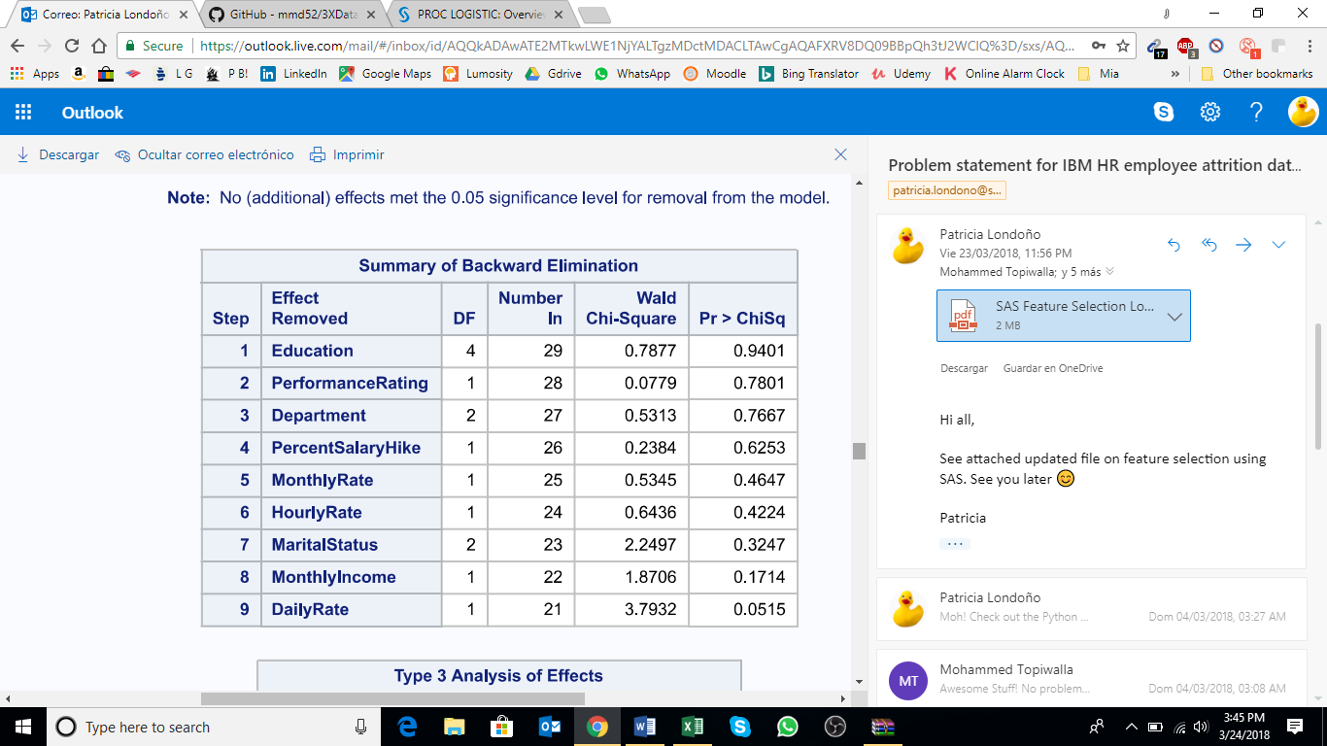

See full report attached [here](https://github.com/mmd52/3XDataMining/blob/master/SAS%20Feature%20Selection%20Logistic%20Model.pdf).

Who made this – Patricia

Who reviewed this – Millicent, Igor

## **Data cleansing and Smote**

Our data set had no missing values therefore no special treatment was required, however since we are running a classification algorithm

1. We had many categorical variables which we needed to convert into dummy variables or ordered integer variables
2. There was a massive class imbalance to the proportion of 83:16 , in order to tackle this we understood that even without any algorithm if we predicted that the employee wouldn’t leave we would still be right 83% of the time. So any model we make should be able to provide a better accuracy than this or else it would not be worth it.
3. The second solution was to balance the classes (A paper by Chawla led us the way - > <https://www.jair.org/media/953/live-953-2037-jair.pdf>)
4. With the help of smote and code help from stack overflow we achieved Smote
   1. What smote does is simple, it first of all takes the class with low proportion and artificially boosts its values to increase the number of records, it tries to generate new rows by replicating them in the bases of a range of values already present making various random combinations
   2. It takes the overpopulated proportion and performs sampling to pick up those rows which are the most representative of the population and then it uses them to reduce this proportion
   3. This is repeated till the classes are nearly balanced
5. Two techniques of smote from 2 different packages were used therefore we have 2 smote data sets

Who made this – Mohammed

Who reviewed this – Sanchita , Igor

## **Classification**

In order to create an early warning system, it was essential to perform a supervised classification.

We had 3 sets of data

1. The original data (With one hot encoding)
2. Data generated from SMOTE (Set1)
3. Data generated from SMOTE (Set 2)

Before running any model it was ensured that the best parameters were selected on the basis of validation set or cross validation set. The splits were always on the basis of 50:25:25 (Training:Validation:Testing). All the sampling is stratified sampling in order to ensure perfect class balance

The approach was to run simple models like

1. Decision tree
2. Logistic Regression

On both these models we would train each of the 3 data sets

After the process was completed we trained data on complex models live

1. Support vector machines
2. Artificial Neural Network
3. Random forest
4. Extreme Gradient Boosting

The output for running all those models are 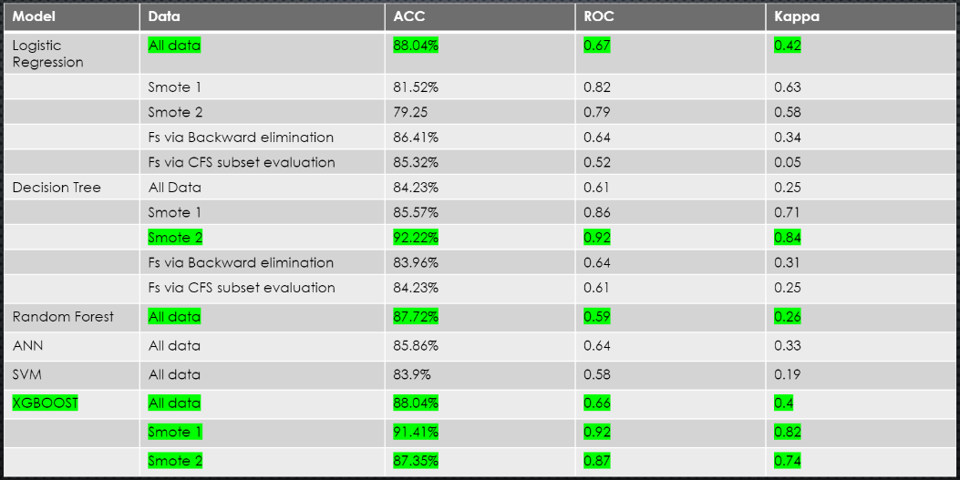

The interpretation is simple SMOTE data is the winner and decision tree stole the show!

But what are we missing at times it may be necessary to explain the HR our results, why our model believes our person is planning to leave, in that case decision tree or logistic regression are the best options.

However, if why decision made was not required we can simply use more powerful models like XGBoost, because as data increases the accuracy of XGBOOST will be higher than a decision tree because it’s a powerful ensemble algorithm.

Who made this – Mohammed

Who reviewed this – Patricia , Valerio

## **Clustering**

For clustering our goal was to check if our dataset falls into 2 perfect clusters or not. If not what additional insights does it provide.

A K-means clustering algorithm was used on the original dataset.

1. The silhouette index tells us about the effectiveness of the classification and using the K-means (with two clusters) on the last set of variables, we obtained a 0.7 (Silhouettes average width).
2. We all pointed out that it was a very good result, plus upon reviewal of the work everyone correctly pointed that we are setting 2 as the number of cluster for testing matters, but the elbow plot at the beginning of the scripts shows that 3 or 4 is the best number to choose.
3. In order to explain such a high silhouette score, a reasoning was done to check why people in the clusters are likely to leave or not leave. Do they have something in common? That would have required further analysis on the clusters. And a future scope of research could be done on this data point

We wanted to work using clustering on this project because we wanted to improve our knowledge on the project and we still feel there is much to learn.

Who made this – Valerio

Who reviewed this – Sanchita , Mohammed

Challenges faced –

* The main difficulty was plotting. When it comes to clustering, plots become hard to code and interpret.
* Luckily enough all group members supported the clustering and a great repository of examples from this course.
* Ultimate struggle faced was also with time. A lot of time was spent learning and correct methods of coding. A lot of simple random bugs took up more time than it should have.

Conclusion of Author-

I wish to take this project out again in the future and try to answer the unanswered questions.

## **Association**

For association rule mining we can have only categorical variables, so to prepare data for association we created a python script located [here](https://github.com/mmd52/3XDataMining/blob/master/DataCleaning_ForAssociation.ipynb) . After the data preparation in Python we realized some more would be needed in Weka, for this we converted the csv file to an arff file and manually changed some variables to categorical which weka interpreted as numerical.

Once the data was ready we wanted to check if there exists some relationship between a certain attribute and attrition, for example does being single imply that an employee would leave or does it imply that being old means an employee would not leave if yes what is the confidence.

We ran an apriori algorithm on the data and the results achieved are [here](https://github.com/mmd52/3XDataMining/blob/master/AssociationWekaOutput.md).

Although the results achieved are not exactly aligned with our expectation and did not yield conclusive results, we found 2 important rules, having high confidence.

1. JobRole=Sales Executive 326 ==> Department=Sales 326 <conf:(1)> lift:(3.3) lev:(0.15) [227] conv:(227.09)

2. JobRole=Research Scientist 292 ==> Department=Research & Development 292 <conf:(1)> lift:(1.53) lev:(0.07) [101] conv:(101.11)

Who made this – Igor

Who reviewed this – Millicent

## **Conclusion**

We walked through all the phases of data mining for our client and created an early warning system with a high accuracy that could help the HR to identify candidates more probable of leaving the company.

Our journey went as –

1. Making the business problem
2. Understanding the data
3. Making a Data Science problem
4. Classification
5. Clustering
6. Association
7. Conclusion

Although the Classification model sits idol in our python notebook, as a future enhancement we can make this python code into a script that sits behind a Django framework.

Such that the HR just has to log into the portal (A webpage) and get returned all those candidates who have a high probability to leave the company.

Who made the presentation – Igor, Millicent

Who made the report - Mohammed

Who reviewed it – All group members